A decision tree is a supervised learning algorithm used for both classification and regression tasks. The tree is constructed by recursively splitting the data into subsets based on the values of the input features, creating a branching structure. Each internal node in the tree represents a feature or attribute, and each leaf node represents a predicted class label or target value. The goal is to create a tree that accurately predicts the target variable based on the input features. The decision tree algorithm is a popular choice for its interpretability, as it allows for easy visualization of the decision-making process.
Decision Tree is a Supervised learning technique that can be used for both classification and Regression problems, but mostly it is preferred for solving Classification problems. It is a tree-structured classifier, where internal nodes represent the features of a dataset, branches represent the decision rules and each leaf node represents the outcome.
In a Decision tree, there are two nodes, which are the Decision Node and Leaf Node. Decision nodes are used to make any decision and have multiple branches, whereas Leaf nodes are the output of those decisions and do not contain any further branches.
The decisions or the test are performed on the basis of features of the given dataset.
It is a graphical representation for getting all the possible solutions to a problem/decision based on given conditions.
It is called a decision tree because, similar to a tree, it starts with the root node, which expands on further branches and constructs a tree-like structure.
In order to build a tree, we use the CART algorithm, which stands for Classification and Regression Tree algorithm.
A decision tree simply asks a question, and based on the answer (Yes/No), it further split the tree into subtrees.
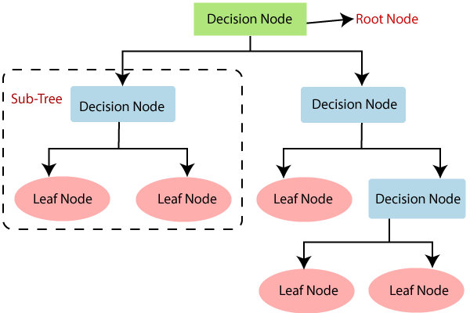

Decision Tree Terminologies:
- Root Node: Root node is from where the decision tree starts. It represents the entire dataset, which further gets divided into two or more homogeneous sets.
- Leaf Node: Leaf nodes are the final output node, and the tree cannot be segregated further after getting a leaf node.
- Splitting: Splitting is the process of dividing the decision node/root node into sub-nodes according to the given conditions.
- Branch/Sub Tree: A tree formed by splitting the tree.
- Pruning: Pruning is the process of removing the unwanted branches from the tree.
- Parent/Child node: The root node of the tree is called the parent node, and other nodes are called the child nodes.

Geometric Intution:
Geometrically we can think decision trees as a set of a number of axis parallel hyperplanes which divides the space into the number of hypercuboids during the inference. we classify the point based on which hypercuboid it falls into.
The statement is describing a way to visualize decision trees using a geometric analogy. It's explaining that you can think of decision trees as a collection of several hyperplanes (flat, high-dimensional surfaces) that are parallel to the coordinate axes. These hyperplanes are used to divide the space (the area where the data points exist) into multiple smaller regions called hypercuboids (hyper-dimensional cubes). When you use a decision tree for making predictions (inference), you classify a data point based on the hypercuboid in which it falls.
In simpler terms, imagine a decision tree as a series of flat, straight cuts in different directions through a multi-dimensional space. These cuts create smaller rectangular regions. Each region corresponds to a specific combination of input features, and the decision tree assigns a label or outcome to each region. So, when a new data point is fed into the decision tree, it follows the cuts and falls into one of these rectangular regions. The label associated with that region becomes the prediction or classification for the new data point.

Sure, let's break down the explanation of decision trees using geometric intuition into points:

1. **Axis-Parallel Hyperplanes**:
- Decision trees can be visualized as a collection of hyperplanes.
- These hyperplanes are parallel to the coordinate axes (X, Y, Z, etc. in multi-dimensional space).

2. **Division of Space**:
- These hyperplanes divide the space (where the data points exist) into multiple smaller regions.
- Each hyperplane acts as a separator, creating boundaries between different regions.

3. **Hypercuboids**:
- The regions formed by these hyperplanes are hypercuboids, which are higher-dimensional analogs of cubes.
- Each hypercuboid corresponds to a set of conditions on the input features.

4. **Inference Process**:
- During the inference or prediction process, a new data point is classified based on the hypercuboid in which it falls.
- The decision tree follows a path from the root to a leaf node, traversing the hyperplanes based on the features of the data point.

5. **Classification Decision**:
- Once the path is determined, the data point falls into a specific hypercuboid or region.
- The label associated with that region (the majority class in a classification task) becomes the prediction for the new data point.

6. **Interpretation**:
- Each decision in the tree corresponds to a split along one of the axes, separating the data into two parts based on a threshold value.
- The hierarchy of decisions forms a tree structure, making it intuitive to interpret and explain the decision-making process.

In essence, decision trees use a series of axis-parallel hyperplanes to partition the feature space into smaller regions, allowing for simple and interpretable classification of data points. This geometric analogy helps in understanding how decision trees make decisions based on input features.
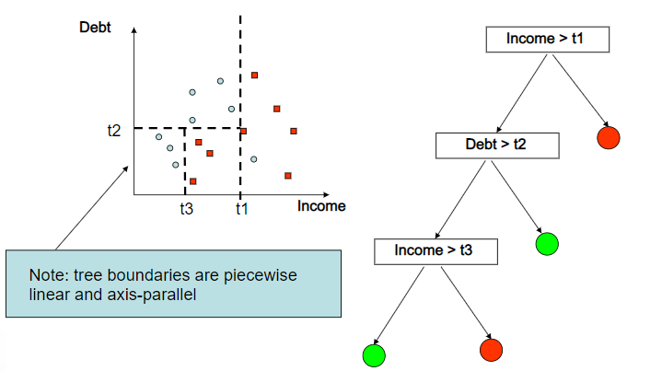

Building a Decision Tree:
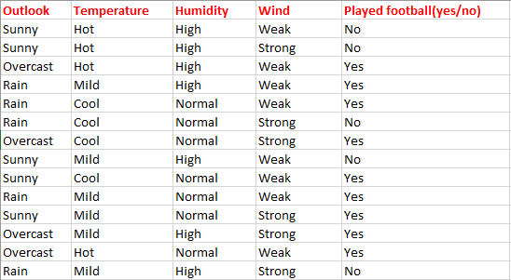
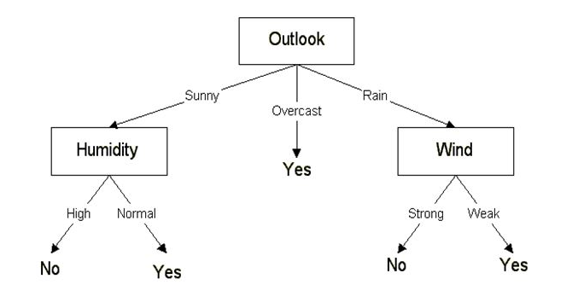

Entropy:
In information theory, the entropy of a random variable is the average level of “information”, “surprise”, or “uncertainty” inherent to the variable’s possible outcomes.
Given a discrete random variable X, with possible outcomes {x1,x2…xn}, which occur with probability P(x1),P(x2)….P(xn) the entropy of X is formally defined as:
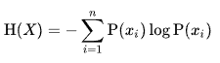
where ∑ denotes the sum over the variable’s possible values. The choice of base for log varies for different applications.
common values of b is, b= 2 or b = e(2.71828)
Where ‘P(xi)’ is simply the probability of an element/class in our data. For simplicity’s sake let’s say we only have two classes, a positive class and a negative class. Therefore ‘i’ here could be either + or (-). So if we had a total of 100 data points in our dataset with 30 belonging to the positive class and 70 belonging to the negative class then ‘P+’ would be 3/10 and ‘P-’ would be 7/10. Pretty straightforward.
If I was to calculate the entropy of my classes in this example using the formula above. Here’s what I would get.
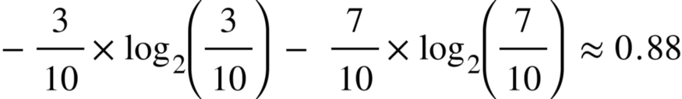
The entropy here is approximately 0.88. This is considered a high entropy , a high level of disorder ( meaning low level of purity). Entropy is measured between 0 and 1.(Depending on the number of classes in your dataset, entropy can be greater than 1 but it means the same thing , a very high level of disorder).

Kullback–Leibler divergence:
KL divergence is the measure of the relative difference between two probability distributions for a given random variable or set of events. KL divergence is also known as Relative Entropy. It can be calculated by the following formula:
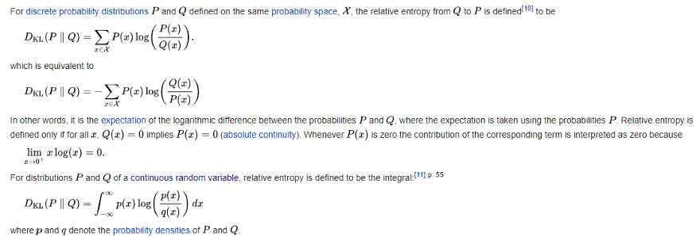
- D(p || q) is always greater than or equal to 0.
- D(p || q) is not equal to D(q || p). The KL-divergence is not communicative.
- If p=q, then D(p || q) is 0.

1. **Definition**: KL Divergence, or Kullback-Leibler divergence, is a statistical measure used to quantify the difference between one probability distribution and a reference probability distribution.

2. **Calculation**: It is a non-symmetric metric that measures the relative entropy or difference in information represented by two distributions, whether continuous or discrete.

3. **Continuous vs. Discrete**: While there are both continuous and discrete forms of KL divergence, in model monitoring, the discrete form is predominantly used. This involves binning data to obtain discrete distributions.

4. **Application in Model Monitoring**: KL Divergence is utilized in monitoring production environments, particularly to ensure that input or output data doesn't significantly deviate from a baseline. It's commonly applied to feature and prediction data.

5. **Independence of Features**: KL Divergence is typically applied to each feature independently, showing how each feature diverges from the baseline values.

6. **Asymmetric Metric**: KL Divergence is asymmetric, meaning that swapping the baseline and sample distributions yields different results. This can complicate troubleshooting and comparison workflows.

7. **Alternatives**: Due to its asymmetry, alternatives like the Population Stability Index (PSI), a symmetric derivation of KL Divergence, are sometimes preferred in model monitoring tools.

8. **Numeric vs. Categorical Features**: KL Divergence can measure differences in both numeric and categorical distributions. Binning strategies and cardinality considerations differ for these types of features.

9. **High Cardinality**: For high cardinality features, alternative monitoring methods like embeddings or focusing on top items with KL Divergence are recommended.

10. **Intuition**: Understanding the intuition behind KL Divergence is important, especially in interpreting changes in the metric based on distribution changes. Movements towards zero have a larger effect relative to industry standard thresholds.

In decision trees, understanding KL Divergence can be valuable for several reasons:

1. **Feature Selection**: Decision trees often involve selecting the most informative features at each node to split the data. KL Divergence can help quantify the difference between feature distributions, aiding in the selection of the most discriminative features.

2. **Splitting Criteria**: When determining the optimal split at each node, decision trees commonly use metrics like Gini impurity or entropy. KL Divergence offers an alternative measure of dissimilarity between distributions, providing flexibility in choosing splitting criteria.

3. **Drift Detection**: Decision trees can be sensitive to changes in data distribution, especially in scenarios where the underlying data evolves over time. KL Divergence can be used to monitor data drift, helping to adapt decision trees to changing environments or detect concept drift.

4. **Interpretability**: Decision trees are known for their interpretability, as the structure of the tree directly represents decision rules. Understanding the role of KL Divergence in feature selection and splitting criteria enhances the interpretability of decision tree models.

5. **Ensemble Methods**: KL Divergence can also be relevant in ensemble methods involving decision trees, such as random forests or gradient boosting. These methods often combine multiple decision trees, and drift detection using KL Divergence can improve the robustness of ensemble models.

Information Gain:
It can be defined as the amount of information gained about a random variable or signal from observing another random variable. It can be considered as the difference between the entropy of parent node and weighted average entropy of child nodes.
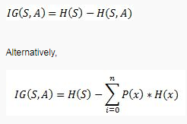
Information Gain, or IG for short, measures the reduction in entropy or surprise by splitting a dataset according to a given value of a random variable.
A larger information gain suggests a lower entropy group or groups of samples, and hence less surprise.
Sure, here are 10 points on information gain:
1. **Definition**: Information gain is a concept used in decision tree algorithms to measure the reduction in uncertainty when a dataset is split based on a particular feature.
2. **Entropy**: It compares the entropy before and after splitting the dataset. Entropy is a measure of disorder or uncertainty in the data.

3. **Splitting Criteria**: Information gain helps decide which feature to split on at each node of a decision tree. The feature that results in the highest information gain is chosen.
4. **Mathematical Formulation**: Information gain is calculated using a formula that considers the entropy of the parent node and the entropy of each child node resulting from the split.
5. **Decision Tree Construction**: It's used recursively to construct decision trees. At each node, information gain is calculated for all available features, and the one with the highest value is selected for splitting.
6. **Bias Towards Features**: Information gain tends to favor features with a large number of unique values because they can partition the data into more homogeneous subsets.
7. **Handling Missing Values**: Information gain can help determine how to handle missing values at each node, whether by treating them as a separate category or imputing them.

8. **Limitations**: It may exhibit bias towards features with many categories and struggle with continuous or highly correlated features, potentially leading to overfitting.
9. **Alternative Measures**: While information gain is common, other criteria like Gini impurity and gain ratio offer different perspectives on feature selection and can help address its limitations.
10. **Practical Importance**: Information gain is crucial for building interpretable and efficient decision tree models. By selecting informative features, it helps construct trees that accurately represent data patterns and make reliable predictions.

Gini impurity:
The Gini impurity (pronounced “genie”) is used to predict the likelihood that a randomly selected example would be incorrectly classified by a specific node. It is called an “impurity” metric because it shows how the model differs from a pure division.
The degree of Gini impurity ranges from 0 to 1.

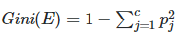

Entropy, relative entropy, information gain, and Gini index are all measures used in decision trees to determine the quality of a split in the tree.
- Entropy: In decision tree analysis, entropy is a measure of impurity in a dataset. The entropy of a dataset is calculated based on the probability of the different classes in the dataset. The entropy of a dataset with a single class is zero, while the entropy of a dataset with two classes is one.
- Relative Entropy: Also known as Kullback-Leibler Divergence (KLD), it's a measure of the difference between two probability distributions. It is used to compare the impurity of two datasets.
- Information Gain: The information gain is the reduction in entropy that occurs when a dataset is split on an attribute. The attribute with the highest information gain is chosen as the root node of the decision tree.
- Gini Index: The Gini index is another measure of impurity in a dataset. It ranges from 0 to 1, with 0 indicating a pure dataset and 1 indicating an impure dataset. In decision tree analysis, the attribute with the lowest Gini index is chosen as the root node of the decision tree.
In general, these measures are used to evaluate different splits in the decision tree and decide which attribute should be used as the root node of the tree. The attribute with the highest information gain or the lowest Gini index is chosen as the root node, which will lead to the most pure child nodes.
the formulas for entropy, relative entropy, information gain, and Gini index:
- Entropy: The entropy of a dataset is calculated using the formula: E = -∑(p(i) * log(p(i))) where E is the entropy of the dataset, p(i) is the probability of class i, and the sum is taken over all classes.
- Relative Entropy (Kullback-Leibler Divergence): The relative entropy between two probability distributions P and Q is calculated using the formula: D(P||Q) = ∑ (p(i) * log(p(i) / q(i))) where D(P||Q) is the relative entropy between P and Q, p(i) and q(i) are the probabilities of class i in the distributions P and Q, and the sum is taken over all classes.
- Information Gain: The information gain for a dataset split on an attribute A is calculated using the formula: Gain(A) = Entropy(parent) - ∑ ( (size of subset / total size) * Entropy(subset)) where Gain(A) is the information gain for attribute A, Entropy(parent) is the entropy of the parent dataset, size of subset is the number of elements in a subset, total size is the number of elements in the parent dataset, and the sum is taken over all subsets created by the split on attribute A.
- Gini Index: The Gini index for a dataset is calculated using the formula: Gini = 1 - ∑(p(i)^2) where Gini is the Gini index for the dataset, p(i) is the probability of class i, and the sum is taken over all classes.
It's important to note that all these formulae are based on a binary classification problem, in case of multi-class classification the entropy and Gini Index will be calculated differently.
The mathematical derivation of decision trees can be divided into two parts: the criterion used to determine the quality of the split, and the algorithm used to construct the tree.
- Split Criterion: The quality of a split is determined by a criterion function, which measures the impurity of the subsets created by the split. Commonly used criterion functions include: a. Entropy: The entropy of a dataset is a measure of impurity, and is calculated as: E = -∑(p(i) * log(p(i))) where E is the entropy of the dataset, p(i) is the probability of class i, and the sum is taken over all classes. b. Gini Index: The Gini index is another measure of impurity, and is calculated as: G = 1 - ∑(p(i)^2) where G is the Gini index of the dataset, p(i) is the probability of class i, and the sum is taken over all classes.
- Tree Construction Algorithm: Once the impurity of the subsets is determined, the tree construction algorithm is used to construct the tree. The most commonly used algorithms are: a. ID3 (Iterative Dichotomiser 3): This algorithm uses entropy as the split criterion and recursively splits the data into subsets based on the feature that maximizes the information gain. b. C4.5: This algorithm is similar to ID3, but uses the gain ratio as the split criterion, which is calculated as the information gain divided by the intrinsic information of the feature. c. CART (Classification and Regression Trees): This algorithm uses the Gini index as the split criterion and constructs binary trees, where each non-leaf node splits the data into two subsets.
Splitting Numerical Features:
The splitting of numerical features can be performed by sorting the features in the ascending order and trying each value as the threshold point and calculating the information gain for each value as the threshold. Finally, if that value obtained is equal to the threshold which gives the maximum I.G value.
Splitting Categorical Features:
In order to handle categorical features in Decision trees, we must never perform one hot encoding on a categorical variable even if the categorical variables are nominal since most of the libraries can handle categorical variables automatically. we can still assign a number for each variable if desired.
Feature scaling (column standardization) not necessary to perform in decision trees. However, it helps with data visualization/manipulation and might be useful if you intend to compare performance with other data or other methods like SVM.
Over-fitting and Under-fitting:
Over-fitting is the phenomenon in which the learning system tightly fits the given training data so much that it would be inaccurate in predicting the outcomes of the untrained data.
In decision trees, over-fitting occurs when the tree is designed so as to perfectly fit all samples in the training data set. Thus it ends up with branches with strict rules of sparse data. Thus this effects the accuracy when predicting samples that are not part of the training set.
Underfitting is a modeling error which occurs when a function does not fit the data points well enough. It is the result of a simple model with an insufficient number of training points. A model that is under fitted is inaccurate because the trend does not reflect the reality of the data.
- If Depth is low (=1) it is known as Decision Stump.

Train and Run time complexity of Decision Tree:
Training Time Complexity= O(n*log(n)*d)
n= number of points in the Training set
d=dimentionality of the data
Run-time Complexity= O(maximum depth of the tree)
Note: We use Decision Tree when we have large data with low dimensionality.
Decision Tree Regression: Decision tree regression observes features of an object and trains a model in the structure of a tree to predict data in the future to produce meaningful continuous output. Continuous output means that the output/result.
The decision criteria are different for classification and regression trees. Decision trees regression normally use mean squared error (MSE) to decide to split a node in two or more sub-nodes.
Let’s examine how is Splitting Decided for Decision Trees Regressor in more details. The first step to create a tree is to create the first binary decision. How are you going to do it?
- We need to pick a variable and the value to split on such that the two groups are as different from each other as possible.
- For each variable, for each possible value of that variable see whether it is better.
- How to determine if it is better? Take weighted average of two new nodes (mse*num_samples)
To sum up, we now have:
- A single number that represents how good a split is which is the weighted average of the mean squared errors of the two groups that create.
- A way to find the best split which is to try every variable and to try every possible value of that variable and see which variable and which value gives us a split with the best score.
This is the entirety of creating a decision tree regressor and will stop when some stopping condition (defined by hyperparameters) is met:
- When you hit a limit that was requested (for example max_depth)
- When your leaf nodes only have one thing in them (no further split is possible, MSE for the train will be zero but will overfit for any other set -not a useful model)

Advantages of the Decision Tree
- It is simple to understand as it follows the same process which a human follow while making any decision in real-life.
- It can be very useful for solving decision-related problems.
- It helps to think about all the possible outcomes for a problem.
- There is less requirement of data cleaning compared to other algorithms.

Disadvantages of the Decision Tree
- The decision tree contains lots of layers, which makes it complex.
- It may have an overfitting issue, which can be resolved using the Random Forest algorithm.
- For more class labels, the computational complexity of the decision tree may increase.

Decision trees are a popular algorithm in machine learning because they have several advantages:
- Interpretability: Decision trees are easy to interpret and understand, as the decision-making process is represented visually in the tree structure. This makes it easy for domain experts to understand the model and make predictions.
- Handling missing values and outliers: Decision trees can handle missing values and outliers well, as they split the data based on feature values, rather than relying on a specific set of observations.
- Handling non-linear relationships: Decision trees can handle non-linear relationships between input features and the target variable, as they can partition the feature space into smaller regions and make predictions for each region.
- Handling both categorical and numerical data: Decision trees can handle both categorical and numerical data, as they can split the data based on feature values, regardless of the data type.
- Scalability: Decision trees can be efficiently implemented and scaled to large datasets, making them a popular choice for big data applications.
Due to these advantages, decision trees are widely used in various fields such as finance, healthcare, and marketing.

Issues in decision trees

Avoiding overfitting
Since the ID3 algorithm continues splitting on attributes until either it classifies all the data points or there are no more attributes to splits on. As a result, it is prone to creating decision trees that overfit by performing really well on the training data at the expense of accuracy with respect to the entire distribution of data.
There are, in general, two approaches to avoid this in decision trees: - Allow the tree to grow until it overfits and then prune it. - Prevent the tree from growing too deep by stopping it before it perfectly classifies the training data.
A decision tree’s growth is specified in terms of the number of layers, or depth, it’s allowed to have. The data available to train the decision tree is split into training and testing data and then trees of various sizes are created with the help of the training data and tested on the test data. Cross-validation can also be used as part of this approach. Pruning the tree, on the other hand, involves testing the original tree against pruned versions of it. Leaf nodes are removed from the tree as long as the pruned tree performs better on the test data than the larger tree.
Lets see decision tree with this simple example, It is normal “AND’ operation problem, where ‘A’, ‘B’ are features and “A and B” are corresponding labels.
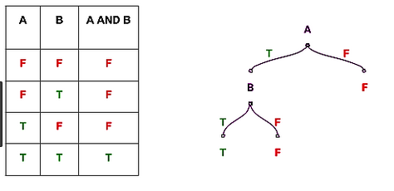
Source Hackerearth
If A=F then result=F
If A=T and B=T, then result=T
If A=T and B=F, then result = F
This is a an example of binary classifier. It classify “And” operation is ‘False’ or ‘True’.
Before diving deeper into the concept lets understand about impurity, types of measures of impurity. it will help us to understand the algorithm better.

Impurity
Let’s understand Impurity with the following toy example,
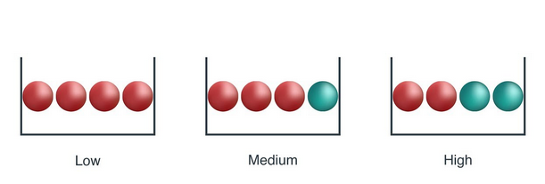

From above image, a ball is randomly drawn from each bowl. So how much information you needed to accurately tells the color of ball. So, left bowl needed less information as all of the ball is red colored, central bowl needed more information than left bowl to tell it accurately, and right bowl needed maximum information as both number of both color ball are same.
As information is measure of purity, so we can say that left bowl is pure node, middle is less impure and right is more impure.
So, how can we measure impurity in sample??
There are couple of impurity measures are there, but in this story we will talk about only two such measure,
- Entropy
- Gini index/ Gini impurity

Entropy
Entropy is amount of information is needed to accurately describe the some sample. So if sample is homogeneous, means all the element are similar than Entropy is 0, else if sample is equally divided than entropy is maximum 1.
So, left bowl has lowest entropy, middle bowl has more entropy and right bowl has highest entropy.
Mathematically it is written as ,
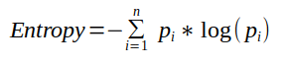

Gini index / Gini impurity
Gini index is measure of inequality in sample. It has value between 0 and 1. Gini index of value 0 means sample are perfectly homogeneous and all element are similar, whereas, Gini index of value 1 means maximal inequality among elements. It is sum of the square of the probabilities of each class. It is illustrated as,
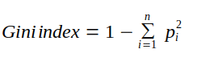
i is number of classes
So what is the importance of impurity measure in decision tree??
Impurity measures the homogeneity in the data sample. If the sample is homogeneous then sample are from same class.

Decision Tree Algorithm
Decision tree algorithm is a tree where nodes represents features(attributes), branch represents decision(rule) and leaf nodes represents outcomes(discrete and continuous).
So how decision tree algorithm are built actually??
There are Various algorithm that are used to generate decision tree from data, some are as following,
- Classification and regression tree CART
- ID 3
- CHAID
- ID 4.5
In this tutorial we will only talk about CART and next tutorial will explain concept of ID3 algorithm. These are mostly used in the industry.
So lets start with a generating a classification tree with the help of CART algorithm,

CART
- It is used for generating both classification tree and regression tree.
- It uses Gini index as metric/cost function to evaluate split in feature selection in case of classification tree.
- It is used for binary classification.
- It use least square as a metric to select features in case of Regression tree.

Decision Tree Assumptions
Several assumptions are made to build effective models when creating decision trees. These assumptions help guide the tree’s construction and impact its performance. Here are some common assumptions and considerations when creating decision trees:

Binary Splits
Decision trees typically make binary splits, meaning each node divides the data into two subsets based on a single feature or condition. This assumes that each decision can be represented as a binary choice.

Recursive Partitioning
Decision trees use a recursive partitioning process, where each node is divided into child nodes, and this process continues until a stopping criterion is met. This assumes that data can be effectively subdivided into smaller, more manageable subsets.

Feature Independence
Decision trees often assume that the features used for splitting nodes are independent. In practice, feature independence may not hold, but decision trees can still perform well if features are correlated.

Homogeneity
Decision trees aim to create homogeneous subgroups in each node, meaning that the samples within a node are as similar as possible regarding the target variable. This assumption helps in achieving clear decision boundaries.

Top-Down Greedy Approach
Decision trees are constructed using a top-down, greedy approach, where each split is chosen to maximize information gain or minimize impurity at the current node. This may not always result in the globally optimal tree.

Categorical and Numerical Features
Decision trees can handle both categorical and numerical features. However, they may require different splitting strategies for each type.

Overfitting
Decision trees are prone to overfitting when they capture noise in the data. Pruning and setting appropriate stopping criteria are used to address this assumption.

Impurity Measures
Decision trees use impurity measures such as Gini impurity or entropy to evaluate how well a split separates classes. The choice of impurity measure can impact tree construction.

No Missing Values
Decision trees assume that there are no missing values in the dataset or that missing values have been appropriately handled through imputation or other methods.

Equal Importance of Features
Decision trees may assume equal importance for all features unless feature scaling or weighting is applied to emphasize certain features.

No Outliers
Decision trees are sensitive to outliers, and extreme values can influence their construction. Preprocessing or robust methods may be needed to handle outliers effectively.

Sensitivity to Sample Size
Small datasets may lead to overfitting, and large datasets may result in overly complex trees. The sample size and tree depth should be balanced.
Lets start with generating classification tree.
Let’s start with weather data set, which is quite famous in explaining decision tree algorithm, where target is to predict play or not( Yes or No) based on weather condition.
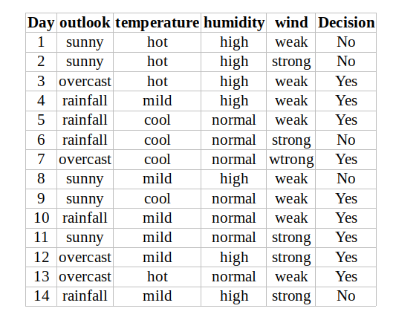
From data, outlook, temperature, humidity, wind are the features of data.
So, lets start building tree,

Outlook
Outlook is a nominal feature. it can take three value, sunny, overcast and rain. Lets summarize the final decision for outlook features,
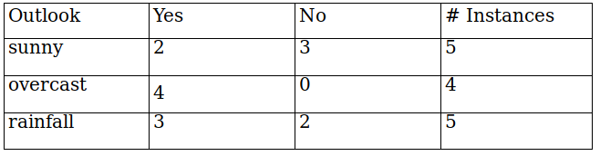
Gini index (outlook=sunny)= 1-(2/5)²-(3/5)² = 1- 0.16–0.36 = 0.48
Gini index(outlook=overcast)= 1- (4/4)²-(0/4)² = 1- 1- 0 = 0
Gini index(outlook=rainfall)= 1- (3/5)² -(2/5)² = 1- 0.36- 0.16 = 0.48
Now , we will calculate the weighted sum of Gini index for outlook features,
Gini(outlook) = (5/14)*0.48 + (4/14) *0 + (5/14)*0.48 = 0.342

Temperature
Similarly, temperature is also a nominal feature, it can take three values, hot,cold and mild. lets summarize the final decision of temperature feature,
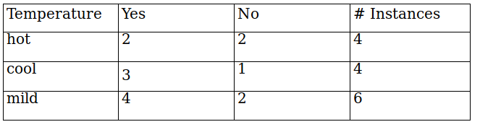
Gini(temperature=hot) = 1-(2/4)²-(2/4)² = 0.5
Gini(temperature=cool) = 1-(3/4)²-(1/4)² = 0.375
Gini(temperature=mild) = 1-(4/6)²-(2/6)² = 0.445
Now, the weighted sum of Gini index for temperature features can be calculated as,
Gini(temperature)= (4/14) *0.5 + (4/14) *0.375 + (6/14) *0.445 =0.439

Humidity
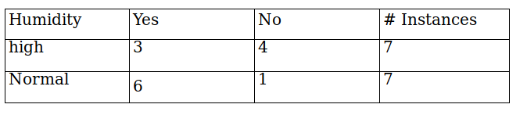
Humidity is a binary class feature , it can take two value high and normal.
Gini(humidity=high) = 1-(3/7)²-(4/7)² = 0.489
Gini(humidity=normal) = 1-(6/7)²-(1/7)² = 0.244
Now, the weighted sum of Gini index for humidity features can be calculated as,
Gini(humidity) = (7/14) *0.489 + (7/14) *0.244=0.367

Wind
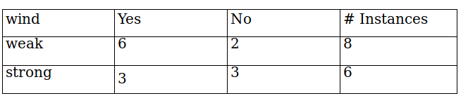
wind is a binary class feature , it can take two value weak and strong.
Gini(wind=weak)= 1-(6/8)²-(2/8)² = 0.375
Gini(wind=strong)= 1-(3/6)²-(3/6)²= 0.5
Now, the weighted sum of Gini index for wind features can be calculated as,
Gini(wind) = (8/14) *0.375 + (6/14) *0.5=0.428

Decision for root node
So,the final decision of all the features,
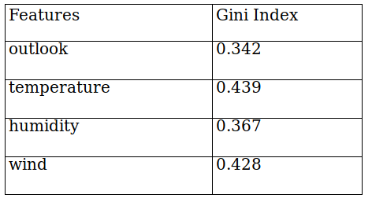
From table, you can seen that Gini index for outlook feature is lowest. So we get our root node.
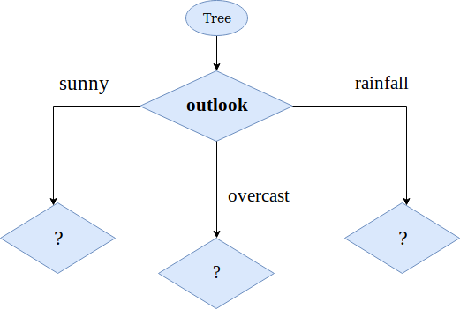
Lets calculate the Gini index on sub data set for outlook feature, as you can seen we have three sub data section, sunny, overcast, and rainfall of outlook feature. we will use same method as above to find next split.
So , lets focus on sub data on sunny outlook feature. we need to find the Gini index for temperature, humidity and wind feature respectively.
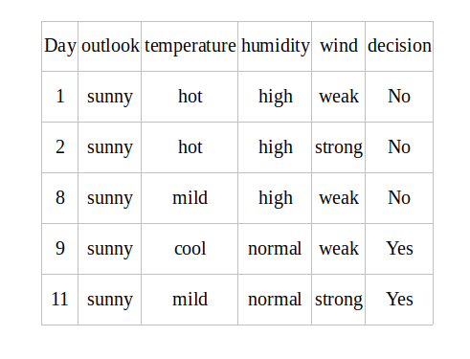

Gini index for temperature on sunny outlook
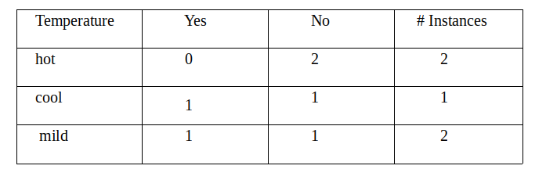
Gini(outlook=sunny & temperature=hot) = 1-(0/2)²-(2/2)² = 0
Gini(outlook=sunny & temperature=cool) = 1-(1/1)²-(0/1)² = 0
Gini(outlook=sunny & temperature=mild) = 1-(1/2)²-(1/2)² = 0.5
Now, the weighted sum of Gini index for temperature on sunny outlook features can be calculated as,
Gini(outlook=sunny & temperature)= (2/5) *0 + (1/5) *0+ (2/5) *0.5 =0.2

Gini Index for humidity on sunny outlook
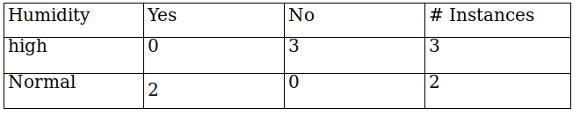
Gini(outlook=sunny & humidity=high) = 1-(0/3)²-(3/3)² = 0
Gini(outlook=sunny & humidity=normal) = 1-(2/2)²-(0/2)² = 0
Now, the weighted sum of Gini index for humidity on sunny outlook features can be calculated as,
Gini(outlook = sunny & humidity) = (3/5) *0 + (2/5) *0=0

Gini Index for wind on sunny outlook
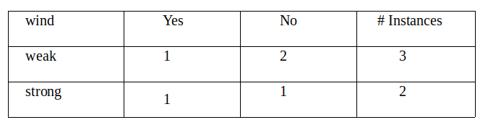
Gini(outlook=sunny & wind=weak) = 1-(1/3)²-(2/3)² = 0.44
Gini(outlook=sunny & wind=strong) = 1-(1/2)²-(1/2)² = 0.5
Now, the weighted sum of Gini index for wind on sunny outlook features can be calculated as,
Gini(outlook = sunny and wind) = (3/5) *0.44 + (2/5) *0.5=0.266+0.2= 0.466

Decision on sunny outlook factor
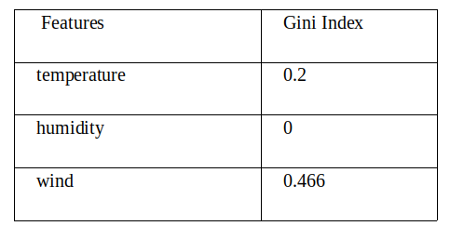
we have calculated the Gini index of all the features when the outlook is sunny. You can infer that humidity has lowest value. so next node will be humidity.
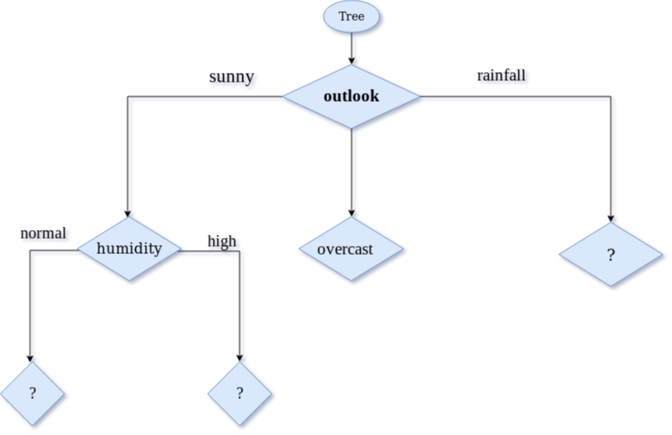
Now,Lets focus on sub data for overcast outlook feature.
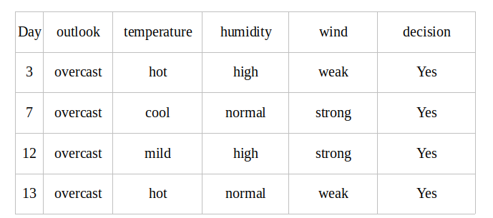
As, you can see from the above table all the decision for overcast outlook feature is always ‘Yes’. Then Gini index for each feature is 0, means it is a leaf nodes.
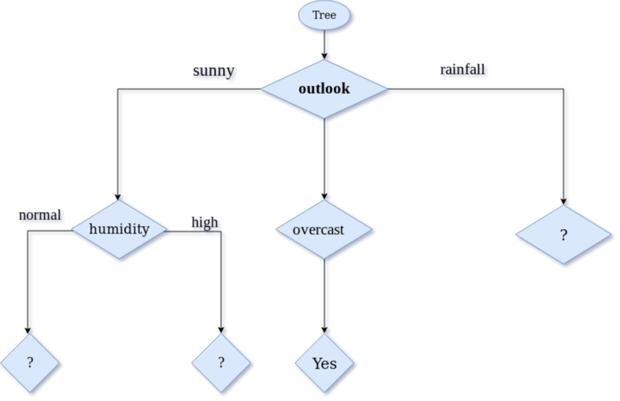
Now,Lets focus on sub data for high and normal humidity feature.
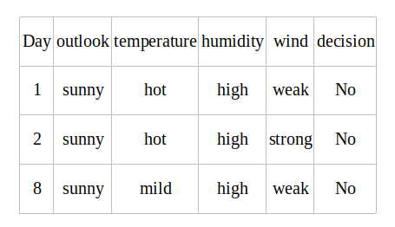
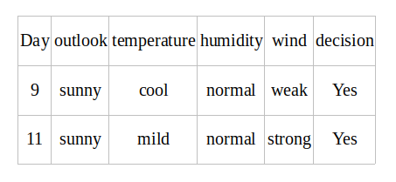
From the given two table, the decision is always ‘No’ when humidity is ‘high’ and decision is always ‘Yes’ when humidity is ‘normal’. So we got leaf node. now decision tree can be viewed as,
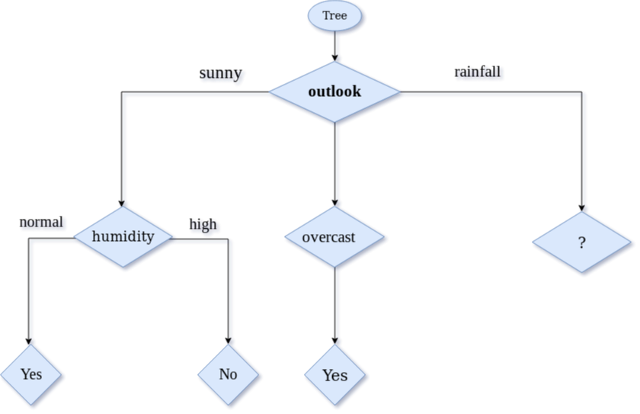
Now,Lets focus on sub data for rainfall outlook feature. we need to find the Gini index for temperature,humidity and wind feature respectively.
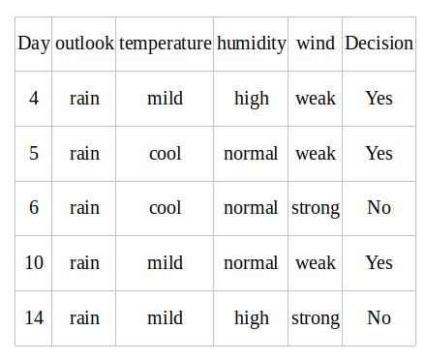

Gini index for temperature for rainfall outlook
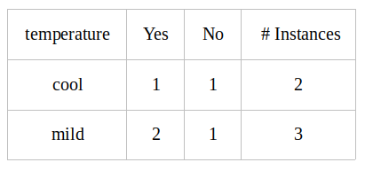
Gini(outlook=rainfall and temp.=Cool) = 1 — (1/2)2 — (1/2)2 = 0.5
Gini(outlook=rainfall and temp.=Mild) = 1 — (2/3)2 — (1/3)2 = 0.444
Gini(outlook=rainfall and temp.) = (2/5)*0.5 + (3/5)*0.444 = 0.466

Gini index for humidity for rainfall outlook
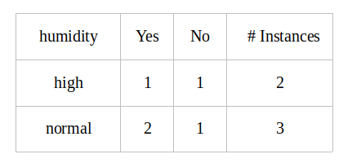
Gini(outlook=rainfall and humidity=high) = 1 — (1/2)2 — (1/2)2 = 0.5
Gini(outlook=rainfall and humidity=normal) = 1 — (2/3)2 — (1/3)2 = 0.444
Gini(Outlook=rainfall and humidity) = (2/5)*(0.5 + (3/5)*0.444 = 0.466

Gini index for wind for rainfall outlook feature
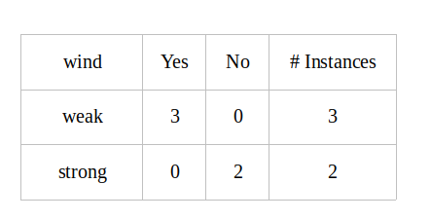
Gini(outlook=rainfall and wind=weak) = 1 — (3/3)2 — (0/3)2 = 0
Gini(outlook=rainfall and wind=strong) = 1 — (0/2)2 — (2/2)2 = 0
Gini(outlook=rainfall and wind) = (3/5)*0 + (2/5)*0 = 0

Decision on rainfall outlook factor
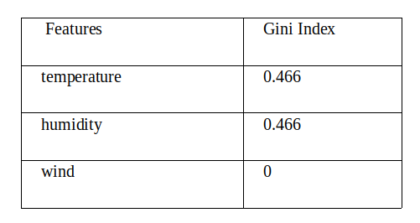
we have calculated the Gini index of all the features when the outlook is rainfall. You can infer that wind has lowest value. so next node will be wind.
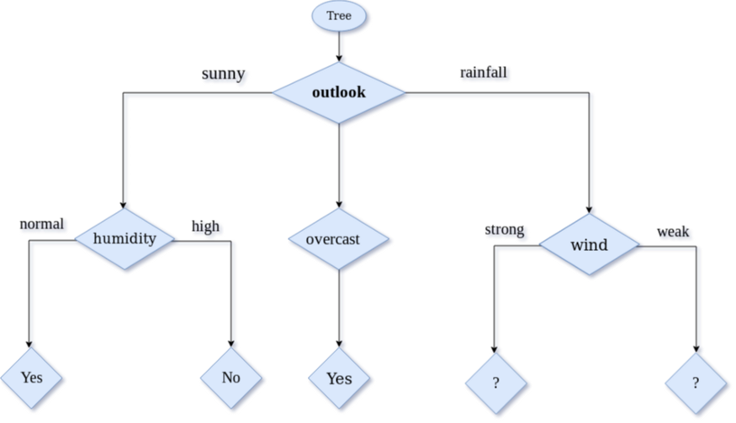
Now,Lets focus on sub data strong and weak for wind rainfall feature.
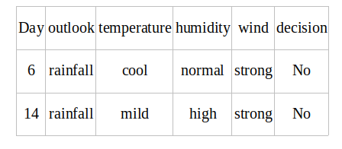
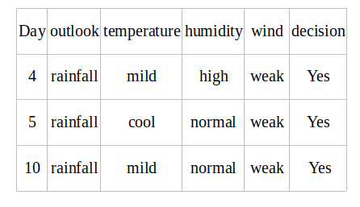
From the above two table, the decision is always ‘No’ when wind is ‘strong’ and decision is always ‘Yes’ when wind is ‘weak’. So we got leaf node.

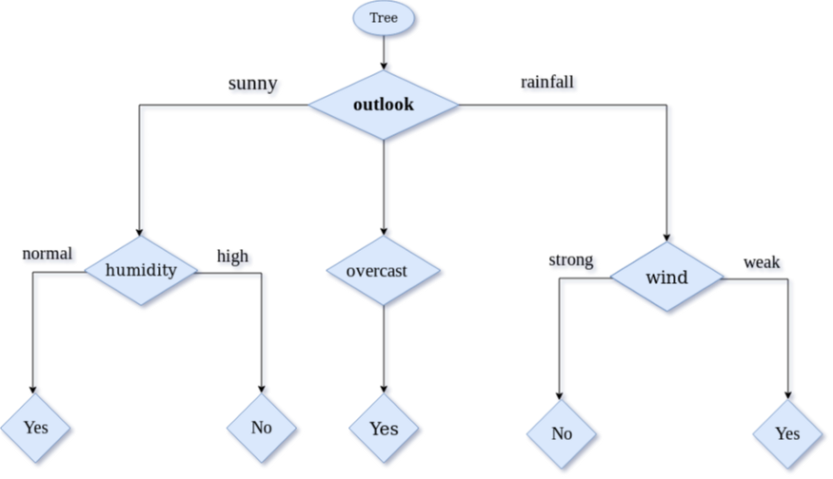

To implement the decision tree algorithm from scratch in Python, you will need to follow these general steps:
- Collect and preprocess the data you will use to train and test the decision tree. This may include cleaning and formatting the data, as well as splitting it into training and testing sets.
- Define a class for the decision tree that includes methods for fitting the tree to the training data, making predictions, and visualizing the tree.
- In the fit method, begin by selecting the root node of the tree. This can be done by finding the feature and split point that result in the largest decrease in impurity.
- Recursively split the remaining nodes by repeating step 3 until a stopping criterion is met (for example, a maximum depth is reached or all the data at a node belong to the same class).
- Create a predict method that traverses the tree and returns a prediction for a given input.
- Create a visualization method that allows you to see the structure of the tree, including the feature and split point used at each node.
- Finally, use the fit method to train the decision tree on your training data, and use the predict method to make predictions on your testing data to evaluate the performance of the model.

The code I provided is an example of how you might implement a decision tree algorithm from scratch in Python. It defines a DecisionTree class that has the following methods:
- __init__(self, max_depth=None): This initializes the decision tree with an optional maximum depth. If max_depth is not provided, the tree will continue to grow until it reaches a stopping criterion.
- fit(self, X, y): This method fits the decision tree to the input data X and labels y. It calls the _build_tree method to construct the tree.
- predict(self, X): This method takes a set of input data X and returns the predicted labels by traversing the tree.
- _build_tree(self, X, y, depth=0): This is the main method that recursively builds the decision tree. It starts by checking if the stopping criterion is met (i.e., the maximum depth is reached or there is only one class in the data). If so, it creates a leaf node with the most common class. If not, it selects the feature and split point that result in the largest decrease in impurity, and splits the data accordingly. It then recursively calls itself on the left and right subtrees.
- _traverse_tree(self, x, node): This method is used to traverse the tree and make a prediction for a single input x. It starts at the root node and follows the left or right branch depending on the value of the feature specified by the current node. If the current node is a leaf node, it returns the value of the leaf.
- _choose_split_point(self, X, y), _split_data(self, feature, split_point), _most_common_class(self, y) are some helper methods which are not implemented in the above code snippet. you could use the impurity measure like Gini impurity or information gain to select the best feature and split point.
- InternalNode and LeafNode are classes that represent internal nodes and leaf nodes in the decision tree, respectively. An internal node has a feature, a split point, and two child nodes (left and right), while a leaf node has a value (the most common class in the data at that node).

